SKILL

AND

JOB

RECOMMENDER

PNT2022TMID26125

**Setting**

**up**

**Application**

**Environment**

**Docker CLI**

**Installation**

Date

19

October

2022

Team

ID

PNT2022TMID26125

Project

Name

Inventory

Mangement for

Retailer

**Step 1.**

Download Docker

from docker.com and install it by running the Docker

Desktop

Installer.exe

file

**Step**

**2.**

Goto

hub.docker.com

register

and

create

an

account

and

login

with

the

same

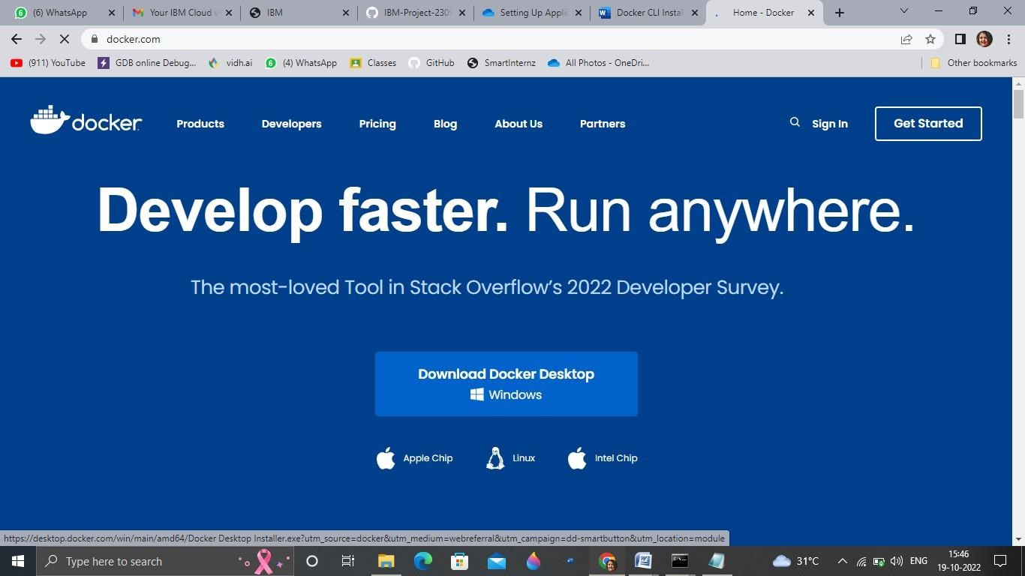

SKILL

AND

JOB

RECOMMENDER

PNT2022TMID26125

**Step**

**3.**

Open

Docker

Desktop

and

start

creating

containers

and

images

